

School of Engineering, Architecture and Information Technology

Bachelor of Science in Computer Engineering

**Portfolio in Seminars and Fieldtrips**

In Partial Fulfillment

Of the Course Requirement in

Seminar and Field Trips

Submitted by

Aaron Bill B. Domingo

Submitted to

Mrs. Milagros S. Constantino

Instructor

**May 2019**

**Narrative/Summative Report of Seminar**

Course Related Seminar Attended

1. “MOBILE APPLICATION DEVELOPMENT”
2. “RASPBERRY PI”
3. “ORIENTATION ON INTELLECTUAL PROPERTY RIGHT”
4. “TECHNOPRENEURSHIP”
5. “CYBERSECURITY”
6. “ROBOTICS”
7. “INTERNET OF THINGS”
8. “ENHANCING COMPETENCIES AND BRINGING COMPUTER GREATER HORIZON”

Course Non-Related Seminar Attended

1. “North Luzon Film Caravan: Nueva Vizcaya”
2. “Seminar on Review of Related Literature and Studies”

VISION-MISSION STATEMENT

OF SAINT MARY’S UNIVERSITY

Saint Mary’s University of Bayombong as a Filipino, Catholic and Missionary Institution of higher learning, draws its vision and orientation from pertinent provisions of the Constitution and mandate of the 1987 Philippine Constitution, Manual of Regulations for Private Higher Education (MORPHE, 2009), the educational goals expressed in the “Education Act of 1982”, the philosophy of the “Commission on Higher Education” and Department of Education, the Apostolic Constitution Ex Corde Ecclesiae on Catholic Universities “ Born from the Heart of the Church”, and the vision-mission and directives on the Educational Apostolate of the Congregation of the Immaculate Heart of Mary (CICM).

VISION

Saint Mary’s University is a premier CICM Catholic Educational institution drawn into communion by the

Wisdom of God, dedicated to forming persons exemplifying excellence, innovation, and passion of Christ’s mission.

MISSION

Using the cascading process of the vision, the mission statements were also reviewed in the light of the aforementioned vision. Hence, the new refined mission statements are the following:

1. Relentlessly pursue quality and excellence in education for local and global relevance and responsiveness.
2. Persistently challenge one another to explore and pursue relevant, innovative and breakthrough ideas through research and development.
3. Steadfastly form and develop community-supportive persons promoting multi-ethnicity, social justice, peace and integrity of God’s creations.
4. Joyfully animate and care for one another as inspired by Mother Mary to become faithful witnesses of Jesus Christ.
5. Conscientiously strengthen good governance and concordance among stakeholders for sustenance of best practices.

OF SCHOOL OF ENGINEERING, ARCHITECTURE

AND INFORMATION TECHNOLOGY

VISION-MISSION STATEMENT

The School is envisioned as a leading institution in providing education and training for the formation of engineers and architects who are globally competitive builders and creators of beauty and efficiency imbued with the values of honesty and integrity. It aims to provide education for engineers and architects in harnessing natural resources and in creating utilities and improvements for the sustainable growth and development of man’s institution, culture and civilization.

OF COMPUTER ENGINEERING

VISION-MISSION STATEMENT

The Computer Engineering program seeks to facilitate the development of well rounded, educated, productive and ethical individuals who are well versed in technology and in social, political and environmental issues. Our goals are to develop within each student a range of professional skills, to provide each with avenues for exploring diverse interest and to launch each successfully into one of a variety of career offering lifelong learning, service and leadership within their own local, national and global communities.

objectives of the seminar

1. To gain knowledge and experience from the speakers.
2. To instill in students that hard work does help to every success.
3. To expose students from new technologies.
4. To prepare students from the exercising their field of interest.
5. To provide students the opportunity to experience and observe what is being done in actual works.

COURSE-RELATED SEMINARS

1. *Title:* “Raspberry Pi”
2. *Theme:* “Seait Week”
3. *Venue:* E201, Saint Mary’s University, Bayombong, Nueva Vizcaya
4. *Date:* November 15, 2018
5. *Participants:* Computer Engineering Students
6. *Proceedings:*

The speaker shared some of his knowledge about the basics of the raspberry pi. Discussed the similarity and differences between the raspberry pi and the Arduino and showed us the G/O pins of the raspberry pi and showed an example.

1. *Insights:*

This seminar made me realized that as a computer engineer, raspberry pi is a micro-computer that I can make experiments with, make some ideas real and show it to the world.

1. *Certificate*

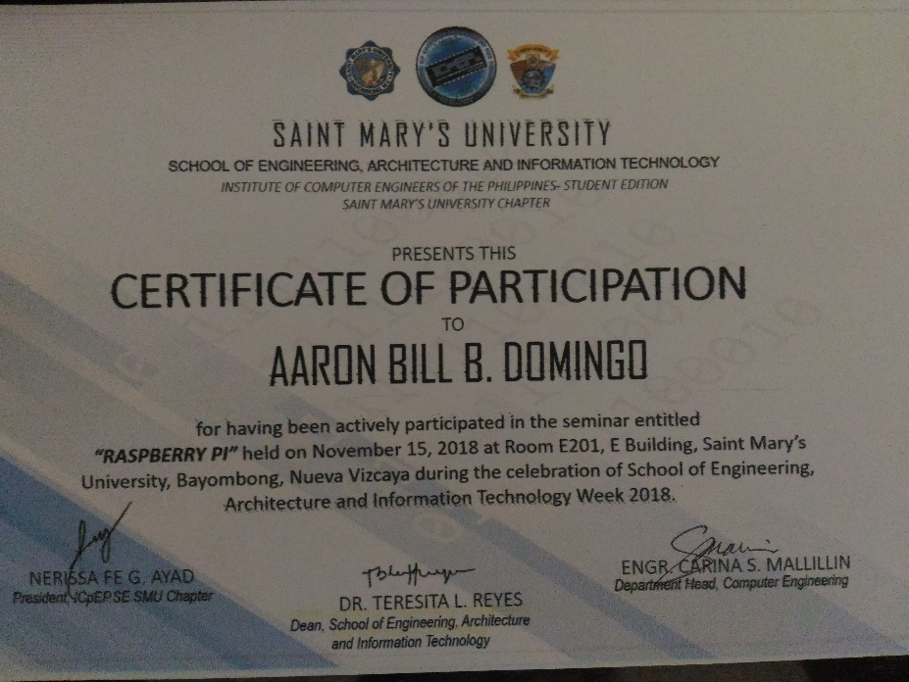

B.

1. *Title:* “Mobile Application Development”
2. *Theme:* “Seait Week”
3. *Venue:* Visual Room 1, Fr. Lambertch Building, Saint Mary’s University, Bayombong, Nueva Vizcaya
4. *Date:* November 13,2018
5. *Participants:* Computer Engineering Students
6. *Proceedings:*

Mobile Application Development vulnerabilities is discussed in this seminar, the speaker shared us its essentials and some important information relating to these matters.

1. *Insights:*

Developing a mobile application will have many vulnerabilities and it is essential to provide a firm security.

1. 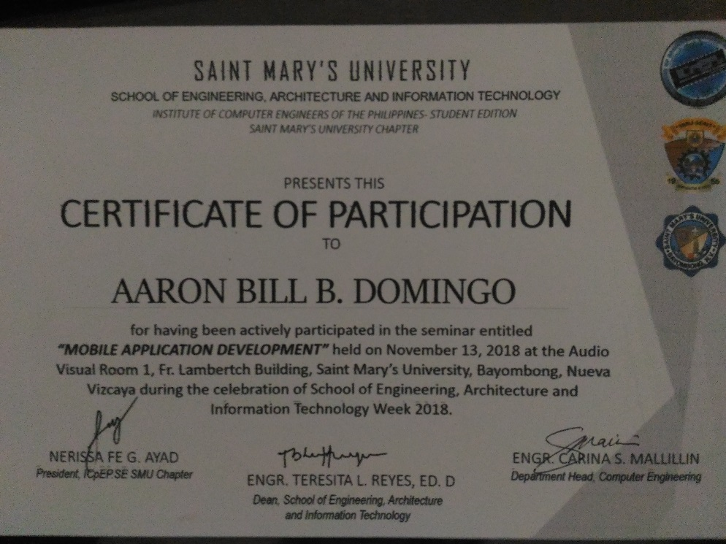*Certificate*

C.

1. *Title:* “ROBOTICS”
2. *Theme:* “Computer Engineers Toward the World of Emerging Technology Breakthroughs and Technology-Oriented Entrepreneurial Growth”
3. *Venue:* Bulwagang Teodulfo Domingo, University of Saint Louis, Tuguegarao City, Cagayan
4. *Date:* November 8-10, 2018
5. *Participants:* Computer Engineering Students
6. *Proceedings:*

In this seminar, the speaker discussed about the importance of robotics and how it helps the world and told us that robotics can be a hobby of an elementary student because there are different varieties of robotics.

1. *Insights:*

Doing or experimenting robotics as a computer engineer, will enhance my overall skills. In addition to that, after this seminar, I had a different perspective in about robotics.

1. *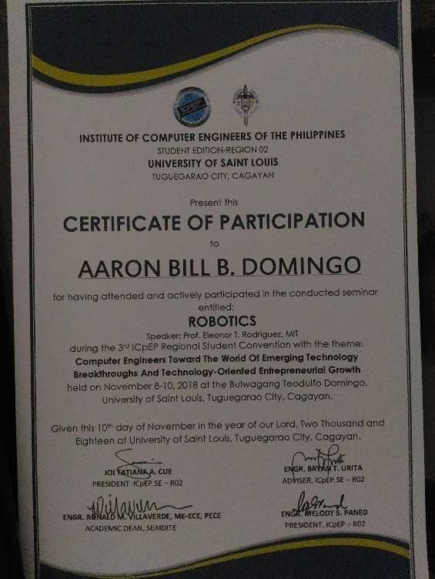Certificate*

D.

1. *Title: “*INTERNET OF THINGS”
2. *Theme: “*Computer Engineers Toward the World of Emerging Technology Breakthroughs and Technology-Oriented Entrepreneurial Growth”
3. *Venue:* Bulwagang Teodulfo Domingo, University of Saint Louis, Tuguegarao City, Cagayan
4. *Date:* November 8-10, 2018
5. *Participants:* Regional Computer Engineering Students
6. *Proceeding:*

The speaker discussed some of how the internet of things work, its technical and policy regarding the things happening in the Internet and a big issue is when threats come and information leaks or security breaks down.

1. *Insight:*

IoT is a system of interrelated computing devices, mechanical and digital machines, objects, animals or people that are provided with unique identifiers ( UIDs ) and the ability to transfer data over a network without requiring human-to-human or human-to-computer interaction.

1. *Certificate:*

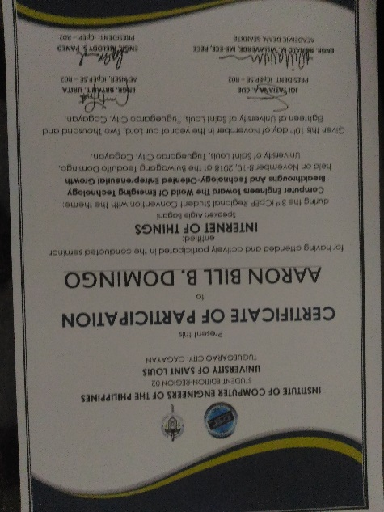

E.

1. *Title: “*CYBERSECURITY”
2. *Theme:* *“*Computer Engineers Toward the World of Emerging Technology Breakthroughs and Technology-Oriented Entrepreneurial Growth”
3. *Venue:* Bulwagang Teodulfo Domingo, University of Saint Louis, Tuguegarao City, Cagayan
4. *Date:* November 8-10, 2018
5. *Participants:* Regional Computer Engineering Students
6. *Proceeding:*

The speaker discussed on what cybersecurity is all about, why is it important and on how to create an effective defense from cyber attacks.

1. *Insight*

*:*

I realized that approaching a successful cybersecurity has its multiple layers of protection spreading across the data that one intends to keep safe, computers, programs and networks.

1. *Certificate:*

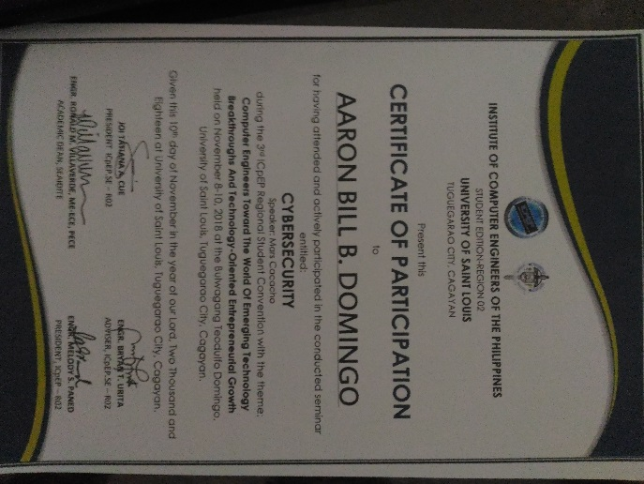

F.

1. *Title: “TECHNOPRENEURSHIP”*
2. *Theme: “*Computer Engineers Toward the World of Emerging Technology Breakthroughs and Technology-Oriented Entrepreneurial Growth”
3. *Venue:* Bulwagang Teodulfo Domingo, University of Saint Louis, Tuguegarao City, Cagayan
4. *Date:* November 8-10, 2018
5. *Participants:* Regional Computer Engineering Students
6. *Proceeding:*

The speaker shared to us his awesome experience in technopreneurship and encouraged us to be a successful technopreneurs someday.

1. *Insight:*

I learned a lot from this seminar and realizes me that I will not be

1. *Certificate*

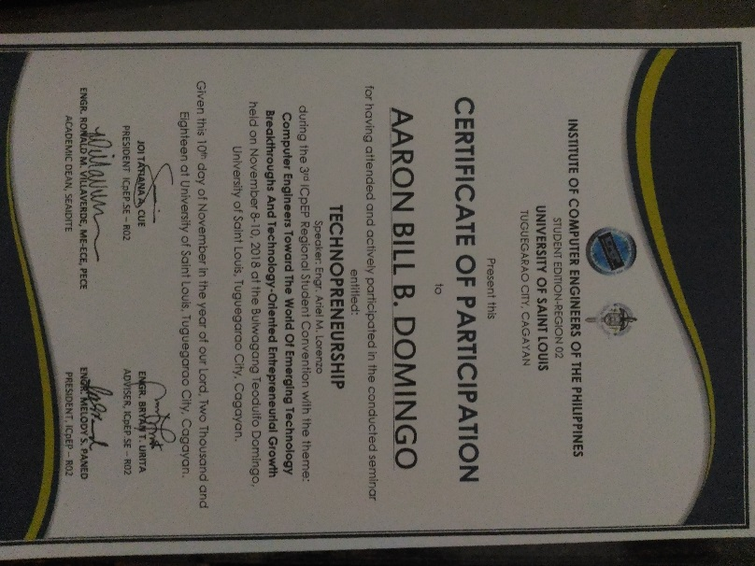

G.

1. *Title: “Enhancing Competencies and Bringing Computer Engineering to Greater Horizon”*
2. *Theme: “*1stICpEP Regional Student Convention”
3. *Venue:* Nueva Vizcaya State University Gymnasium
4. *Date:* November 10, 2016
5. *Participants:* Regional Computer Engineering Students
6. *Proceeding:*

Research report is designed to identify the specific management behaviors that line managers need to show for enhancing employee engagement in the workplace.

1. *Insight:*

This knowledge we gained in this seminar provided us some hints that we can use in our future projects wherein a small and control systems.

1. *Certificate*

**NONRELATED SEMINARS**

1. *Title:“Patuloy sa paghatid saya at pamamhagi ng kwentong natatangi”*
2. *Theme: “*Spag Week”
3. *Venue:* Saint Mary’s University
4. *Date:* September 24, 1015
5. *Participants:* Regional Computer Engineering Students
6. *Proceeding:*

Ang pagsulat ng maikling kuwento, mga bahagi ng ating kultura. Isinasalaysay ng panitikim and buhay, pamumuhay,lipunan, pamahalaga, panananmpalatayam\, at mga kasaranasang kaugnay ng ibat iabng uri ng damdamin .

1. *Insight:*

Ang panitikan sa Pilipinas ay pangunahahing tumutukoy sa umiiral, umuulad, at namamayaning uri at anyo.

1. *Certificate*
2. *Title:“North Luzon Film Caravan:Nueva Vizcaya”*
3. *Theme: “*Seait week”
4. *Venue:* AVR 1, Saint Mary’s University
5. *Date:* November 15,2018
6. *Participants:* Seait
7. *Proceeding:*

To discover, encourage, and support the filmmakers from the region that articulate, interpret and express the Filipino cultural heritage.

1. *Insight:*

This seminar we learn how to entiries must reflect the Filipino cultural heritage, issues and identity with running time not more than 15 minutes including the opening & closing credits.

1. *Certificate*

C.

1. *Title: “Seminar on Review of Related Literature and Studies”*
2. *Theme: “*Seait week”
3. *Venue:* Sacred Heart Center, , Saint Mary’s University
4. *Date:* September 26,2018
5. *Participants:* Seait
6. *Proceeding:*

In this Seminar the characteristics to present the related literature and studies after the thorough and in depth search done be the researchers. This will also present the synthesis of the art.

1. *Insight*

So a review of previous studies in relevant area the present study attempted and presented in this chapter. Need for review of the related literature.

1. *Certificate*